Software Requirement Specifications

Habit Chain – An AI-Powered Habit Tracking System



Submitted by:
Shaheera (F22BINFT1M01072)
Submitted to:
Sir Muzammil

Department of Information Technology
Faculty of Computing
The Islamia University of Bahawalpur

Meeting Details
Sr No | Details |  | Date | Supervisor Signature
1 | Initial Discussion
2 | Requirements Review
3 | Design Approval
4 | Development Review
5 | Final Evaluation
6 | Submission

Summary
This Software Requirements Specification (SRS) outlines the design, purpose, and requirements of Habit Chain – An AI-Powered Habit Tracking System. The system is a Django-based web application that allows users to track daily habits, maintain streaks, and receive AI-powered insights to boost motivation and productivity. Built entirely with Django, Django REST Framework, HTML/CSS, SQLite, and the OpenAI API, the system integrates traditional habit tracking with AI-driven feedback.
Habit Chain allows users to manage habits, view streaks, interact with an AI chat assistant, and receive AI-generated motivational quotes and weekly progress reports. This document includes functional requirements, non-functional requirements, use cases, and the process flow for the complete system.

Table of Contents
- Introduction
1.1 Purpose
1.2 Scope
1.3 Product Perspective
1.4 User Characteristics
1.5 Similar Apps / Literature Review
1.6 Proposed Technologies
- Requirements
2.1 Functional Requirements
2.2 Non-Functional Requirements
- Use Cases and Flow of Processes
3.1 Use Case 1 – User Signup
- References

1. Introduction
Habit Chain is a modern habit-building web application developed using Django. Its purpose is to help users develop consistent and productive routines by tracking habits daily and motivating them through AI-powered features.
Unlike traditional habit trackers, Habit Chain integrates the OpenAI API to provide AI chat assistance, personalized motivational quotes, and AI-generated progress reports based on the user’s data. This improves engagement and helps users stay consistent with their routines.

1.1. Purpose
The goals of Habit Chain are:
- To help users create, track, and manage daily habits effectively.
- To provide AI-powered motivation using the OpenAI API.
- To generate AI-based insights and weekly performance summaries.
- To improve consistency through an automated streak tracking system.
- To offer a user-friendly, responsive, and interactive platform.

1.2. Scope
Included in the Project:
- User Registration & Login (Django Auth)
- Habit creation, update, deletion
- Daily habit completion tracking
- Automatic streak calculation
- AI Chat Assistant using OpenAI API
- AI-generated motivational quotes
- AI weekly progress reports
- REST API endpoints using Django REST Framework
- Admin-side user & data management

1.3. Product Perspective
Habit Chain is a standalone web system structured as follows:
- Frontend: HTML & CSS
- Backend: Django + Django REST Framework
- Database: SQLite
- AI Integration: OpenAI API
- Authentication: Django built-in authentication system
The system modules integrate to form a seamless user experience where users track habits and receive meaningful AI-driven insights.

1.4. User Characteristics

Regular User
- Can create/manage habits.
- Can track daily progress.
- Can view streaks.
- Can chat with AI assistant.
- Can request AI motivational quotes.
- Can view AI progress reports.

Admin
- Manages all users.
- Monitors habits and system data.
- Does not interact with AI features.

1.5. Similar Apps / Literature Review
App | Features | Limitations
Habitify | Habit tracking, reminders | Lacks AI personalization
Habitica | Gamified habit system | Too gamified, not analytical
Streaks | Simple daily tracking | Limited insights
Fabulous | Behavioral science based | Mostly paid; AI not deep
Habit Chain improves these by offering:
- AI chat assistant
- AI motivational quotes
- AI-based weekly progress analysis
- Full free academic implementation

1.6. Proposed Technologies
Category | Technology
Backend | Django
API Layer | Django REST Framework
Database | SQLite
Frontend | HTML, CSS
AI | OpenAI API
Authentication | Django Auth

2. Requirements
Habit Chain enables users to track habits, maintain streaks, and receive AI-powered insights. The system ensures smooth interaction through clean UI, REST API integration, and secure authentication.

2.1. Functional Requirements

FR001 – User Signup
- Purpose: Allow users to register.
- Inputs: Name, Email, Password.
- Users: User.
- Output: New user account created.

FR002 – User Login
- Purpose: Authenticate user.
- Input: Email & Password.
- Output: Access to dashboard.

FR003 – Create Habit
- Purpose: Add new habit.
- Input: Habit name, category, frequency.
- Output: Habit saved.

FR004 – Delete Habit
- Purpose: Remove habit from list.
- Output: Habit deleted.

FR005 – Track Habit Daily
- Purpose: Mark habit as completed each day.
- Output: Updated streaks & progress.

FR006 – Streak Calculation
- Purpose: Automatically update streaks.
- Output: Current & longest streak.

FR007 – AI Chat Assistant
- Purpose: User interacts with AI.
- Input: User message.
- Output: AI-generated reply.

FR008 – AI Motivational Quotes
- Purpose: Generate personalized motivational text.
- Output: AI-based motivational quote.

FR009 – AI Weekly Progress Report
- Purpose: Analyze user streaks and completion data.
- Output: AI-generated weekly summary.

FR010 – Admin Panel
- Purpose: Manage users and data.
- Output: Updated system records.

2.2. Non-Functional Requirements

Security
- Password hashing (Django).
- Secure authentication.

Performance
- System must respond within 2–3 seconds per action.
- AI responses must load within 5 seconds.

Usability
- Clean and minimal UI.
- Easy navigation and readability.

Reliability
- System must handle habitual daily updates without loss.

Maintainability
- Django modular structure.
- Separated API and UI layers.

Scalability
- AI features can be expanded with more models.

Portability
- Works on any major browser.

3. Use Cases and Flow of Processes

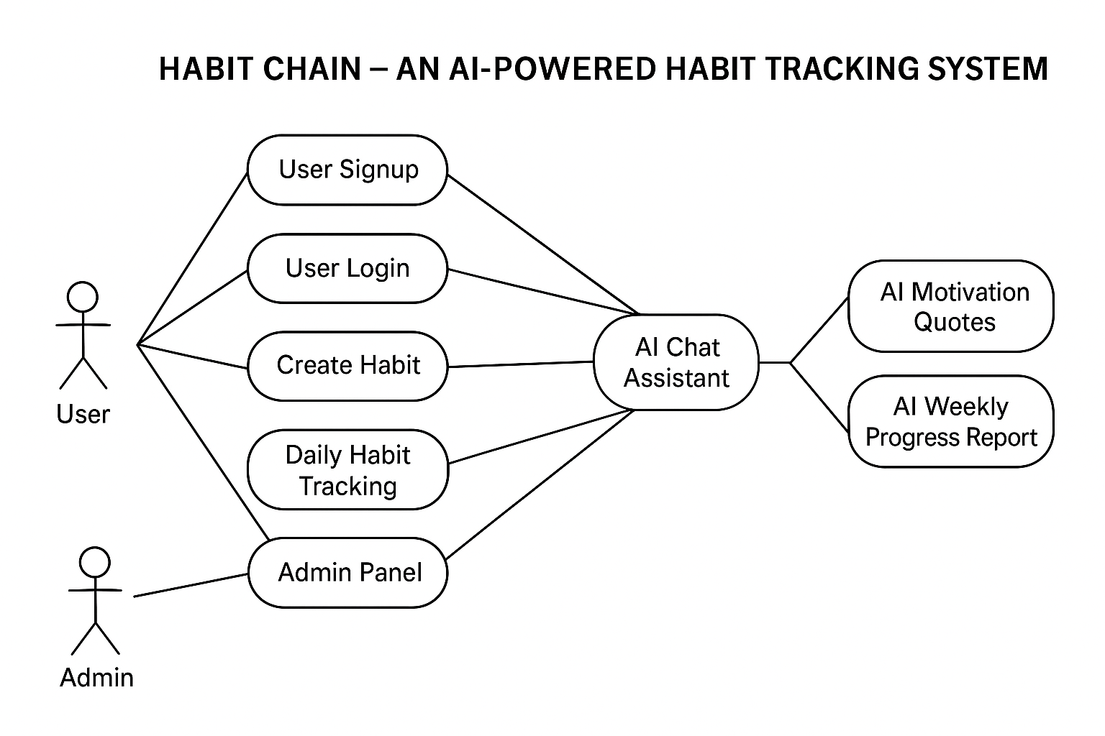

3.1 Use Case 1 – User Signup
Field | Description
ID | UC001
Name | User Signup
Actor | User
Description | User registers for a new account
Requirements | FR001
Precondition | User is not registered
Postcondition | New account is created

Basic Flow
- User opens signup page.
- Enters name, email, and password.
- System validates data.
- System creates the user.
- User is redirected to login.

Exceptions
- Email already exists.
- Invalid password.
- Server error.

4. References
- Django Official Documentation
- Django REST Framework Documentation
- OpenAI API Documentation
- Habit Tracking Behavioral Studies
- IEEE SRS Standard Templates

